Name: Date:
Kindergarten

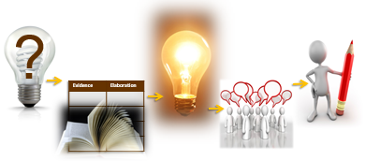

Based on the Writing for Understanding Approach, Vermont Writing Collaborative ©2011

Class Research Project on
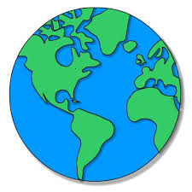
Keeping our Earth Healthy

Class Research Question
How can I take care of the earth’s land?
Becoming an Expert
Class Research Packet
An expert is someone who knows a lot about a particular topic. Follow these steps to become an expert.

Becoming an Expert
An expert is someone who knows a lot about a particular topic.
✓  Done | Steps
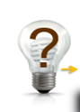
Where am I going?

Text Structure
 | First Read
 | Close Read
 | Thrilling Three
 | 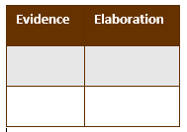 Reading for Evidence
 | Recording Evidence
 | 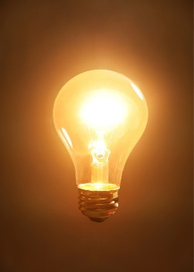 The Focus Statement
 |  Working with Evidence

 | Where Am I Going?  I can use sources to participate in a research project. (W.K.8)

Research Question: How can I take care of the earth’s land?

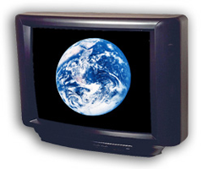


books | internet | videos

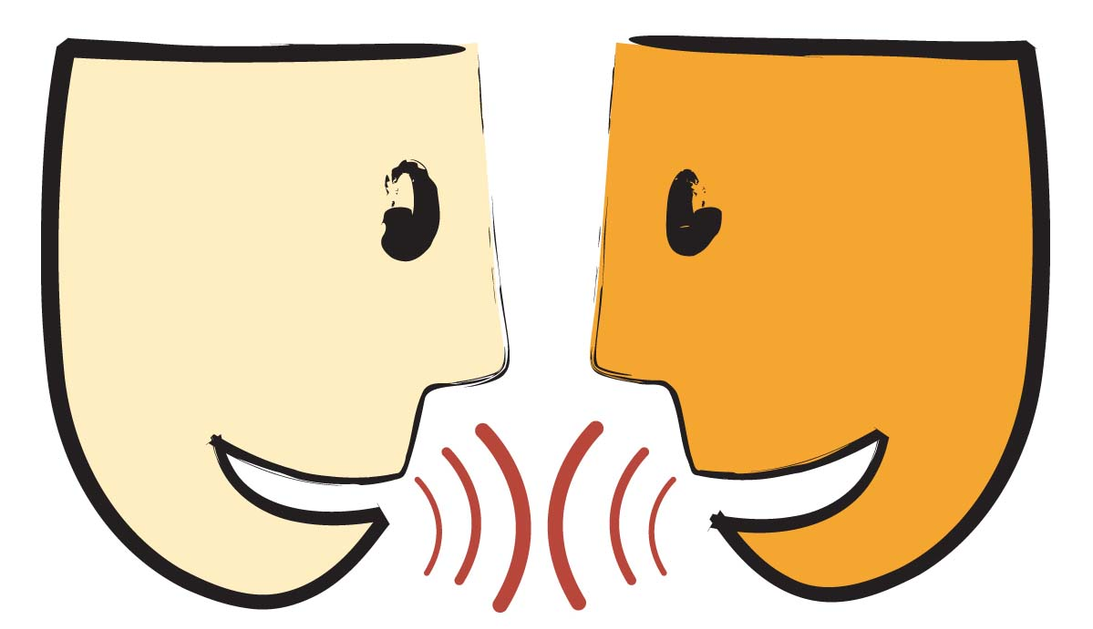
Turn and Talk: How can this source help you answer your research question?

Title: _______________________________________________________________________

_______________________________________________________________________

Author:
_______________________________________________

 | Text Structure  I can find parts of a text. (RI.K.5)

Circle what page number a reader will find information about clean water.

Circle the heading on this page.

.

Circle the photograph.
Circle the caption.
Circle the word in bold.

First Read
I can listen to a text read aloud. (RF.K.4)
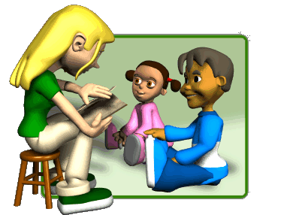
Listen closely as your teacher reads the text aloud.

Close Read
I can answer questions about a text. (RI.K.1)

Why did the author ask: But what else can we do?
Using the photograph, what is an example of a plastic (or paper)

that can be recycled? Write your answer or draw a picture.
How is reusing an item different than recycling?
What are some things that can be reused? Write your answer or draw a picture.
Which item can be reused and which one can be recycled?
Circle the correct word for each picture.


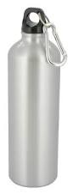
Recycle or Reuse Recycle or Reuse

How is reusing food helpful to the land?

Thrilling Three
I can use words I learned in a sentence. (L.K.6)

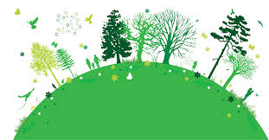
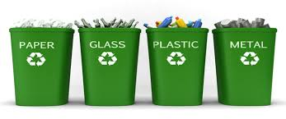
What are some important words in this text?
Caring for our land, air, and water

_______________________________
Making new things with old paper, glass, and plastic

________________________________
Use something again

________________________________
Reading for Evidence
I can gather information to answer a research question. (W.K.8)
Research Question: How can I take care of the earth’s land?
Look


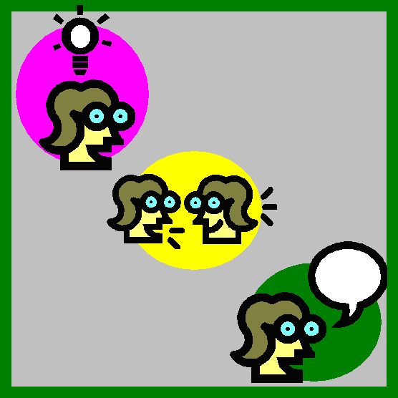


Idea | Examples

Sticky note on evidence
Think and Discuss

Recording Evidence
I can record information to answer a research question. W.K.8


Your teacher will record the evidence on a large chart paper. It will look like the chart below.

The Focus Statement
I can answer a research question using information that I gathered. (W.K.8)

Research Question: How can I take care of the earth’s land?

Turn and talk with your partner about what you think is the ‘big idea”.

A focus statement tells what you have learned from your research in a single sentence.

Focus Statement:

_____________________________________________________________

_____________________________________________________________
Working with Evidence
I can speak in a complete sentence using ideas from my notes. (SL.K.6)
I can use words I learned through reading and discussions. (L.K.6)

Your teacher has pictures or items for you to work with. As you practice working with the evidence you will talk in complete sentences. You can use the sentence frame to help you.

I can ___________ by _____________.

Now you are ready to write!
Use your Writing Resource Packet to write about your research. Check off each step when you complete it.



